

**User Manual: TUP Data Filter System**

Created by: Kyle Christian O. De Castro

**Introduction**

The TUP Data Filter System is a web-based application built using Streamlit. It allows users to upload and filter Excel data, visualize the filtered data using bar graphs, and download the filtered data as a CSV file. This user manual provides a detailed guide on how to use the TUP Data Filter System effectively.

**Table of Contents**

1. System Requirements
2. Installation
3. Login
4. Uploading Excel Data
5. Filtering Data
6. Visualizing Data
7. Downloading Filtered Data
8. File History
9. Logging Out
10. **System Requirements**

Before using the TUP Data Filter System, ensure that your system meets the following requirements:

* Python 3.x installed
* Required packages installed (Streamlit, Pandas, Matplotlib, Seaborn, PIL, Base64, SQLite3)

1. **Installation**

To install the required packages, run the following command in your command prompt (in Administrator mode):



1. **Login**

* Open the command prompt or terminal.
* Navigate to the directory containing the TUP Data Filter System code.
* Run the following command to start the application:



Replace <filename>.py with the name of the file containing the TUP Data Filter System code.

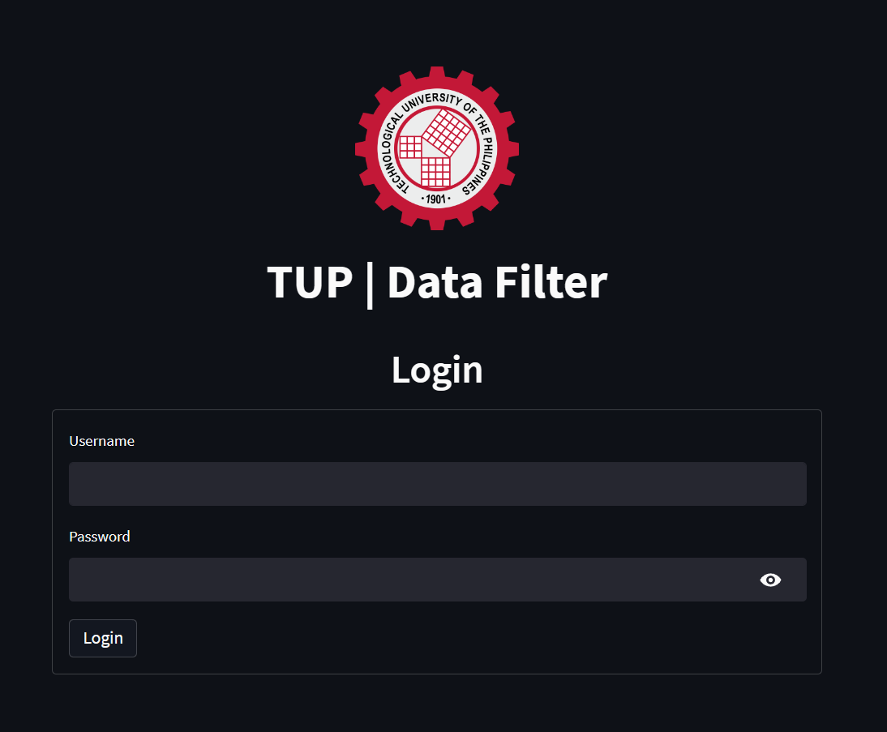

* The application will start, and you will see the login page.
* Enter your username and password in the provided fields.
* Click the "Login" button.
  + If the provided credentials are correct, you will be logged in and can proceed to use the system.
  + If the provided credentials are incorrect, an error message will be displayed. Please try again with the correct credentials.

1. **Uploading Excel Data**
   * 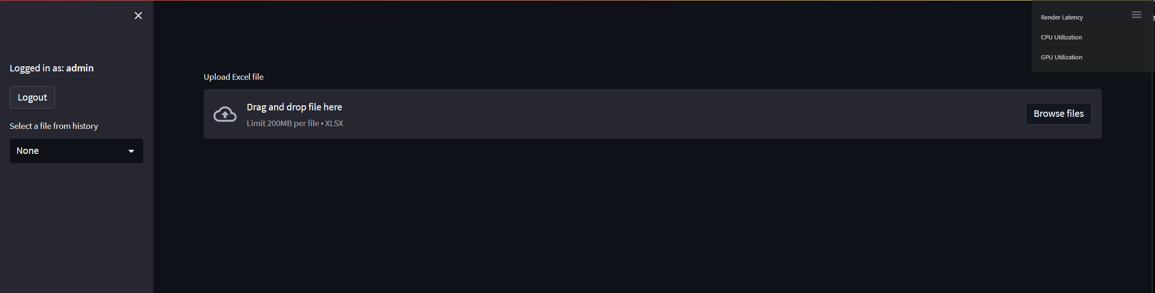After logging in, you will see the main interface of the TUP Data Filter System.
   * To upload an Excel file, click the "Upload Excel file" button.
   * Select the desired Excel file from your local machine and click "Open".

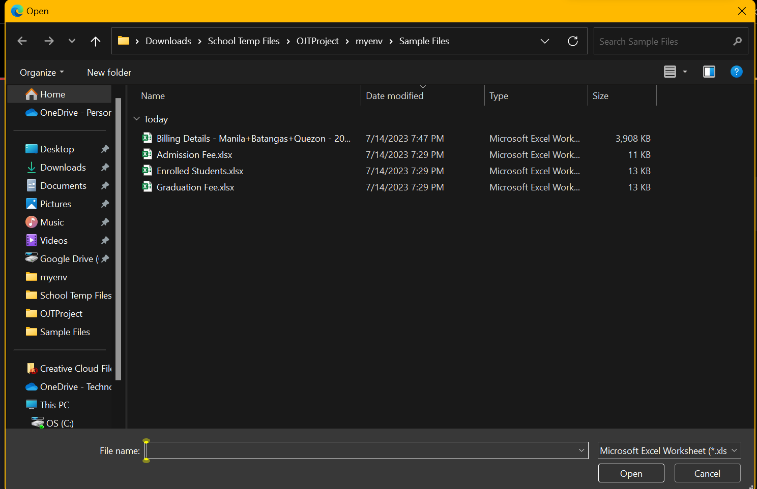

* + The supported file format is .xlsx.
  + 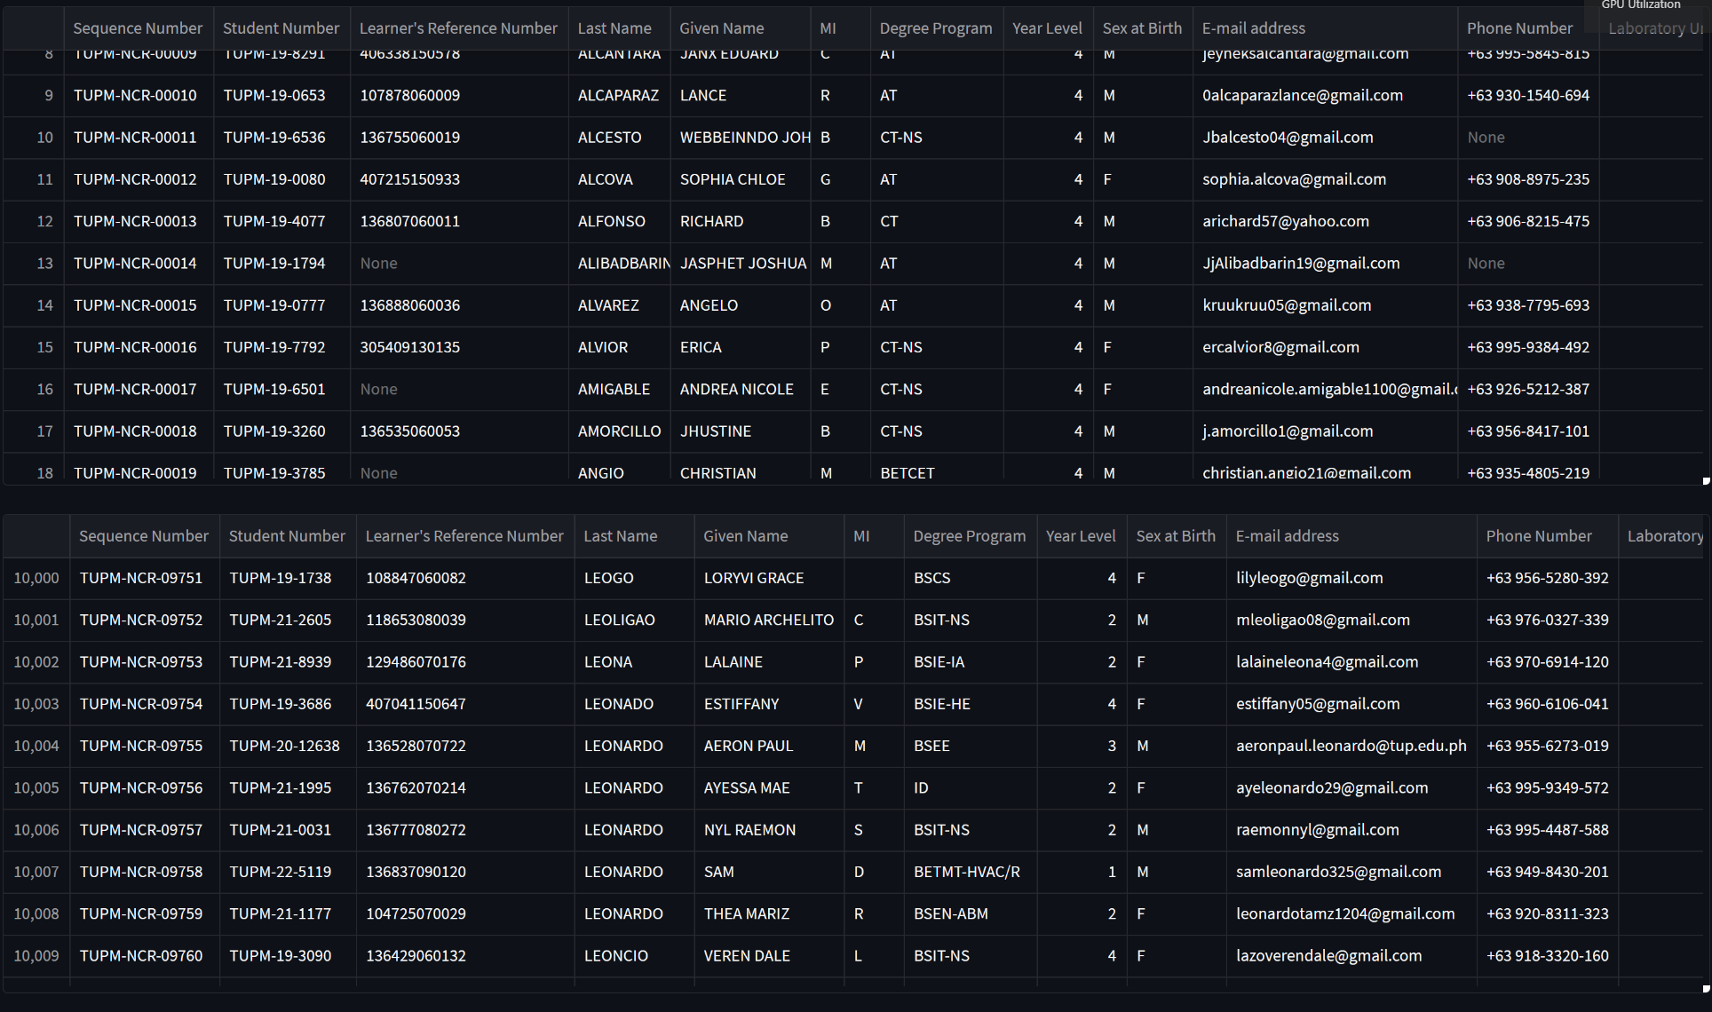The uploaded file will be displayed, and data filtering options will be available.

1. **Filtering Data**
   * The data from the selected sheet will be displayed in chunks.
   * Use the scrollbar to navigate through the data.
   * 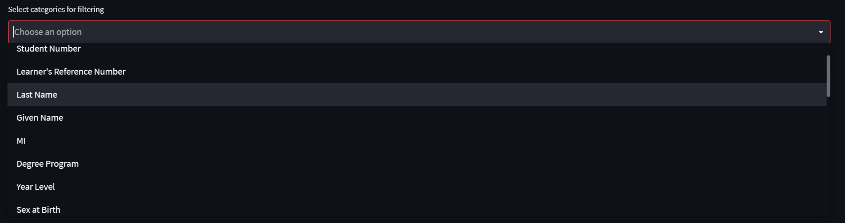Choose the categories for filtering by selecting them from the "Select categories for filtering" multi-select dropdown.
   * Enter the search filters for each selected category in the provided text input fields.
   * The search filters are case-insensitive and support partial matching.
   * Select the category for the bar graph from the "Select category for bar graph" dropdown.
   * Click the "Apply Search Filter" button to apply the filters and display the filtered data and bar graph.
   * If no results are found, a message stating "No results found" will be displayed.
   * Adjust the chunk size if needed by modifying the chunk_size variable in the code.
   * Larger chunk sizes may require more system resources but allow for faster processing.
2. **Visualizing Data**
   * After applying the search filters, the filtered data will be displayed below the search filters section.

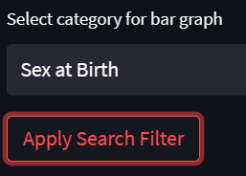

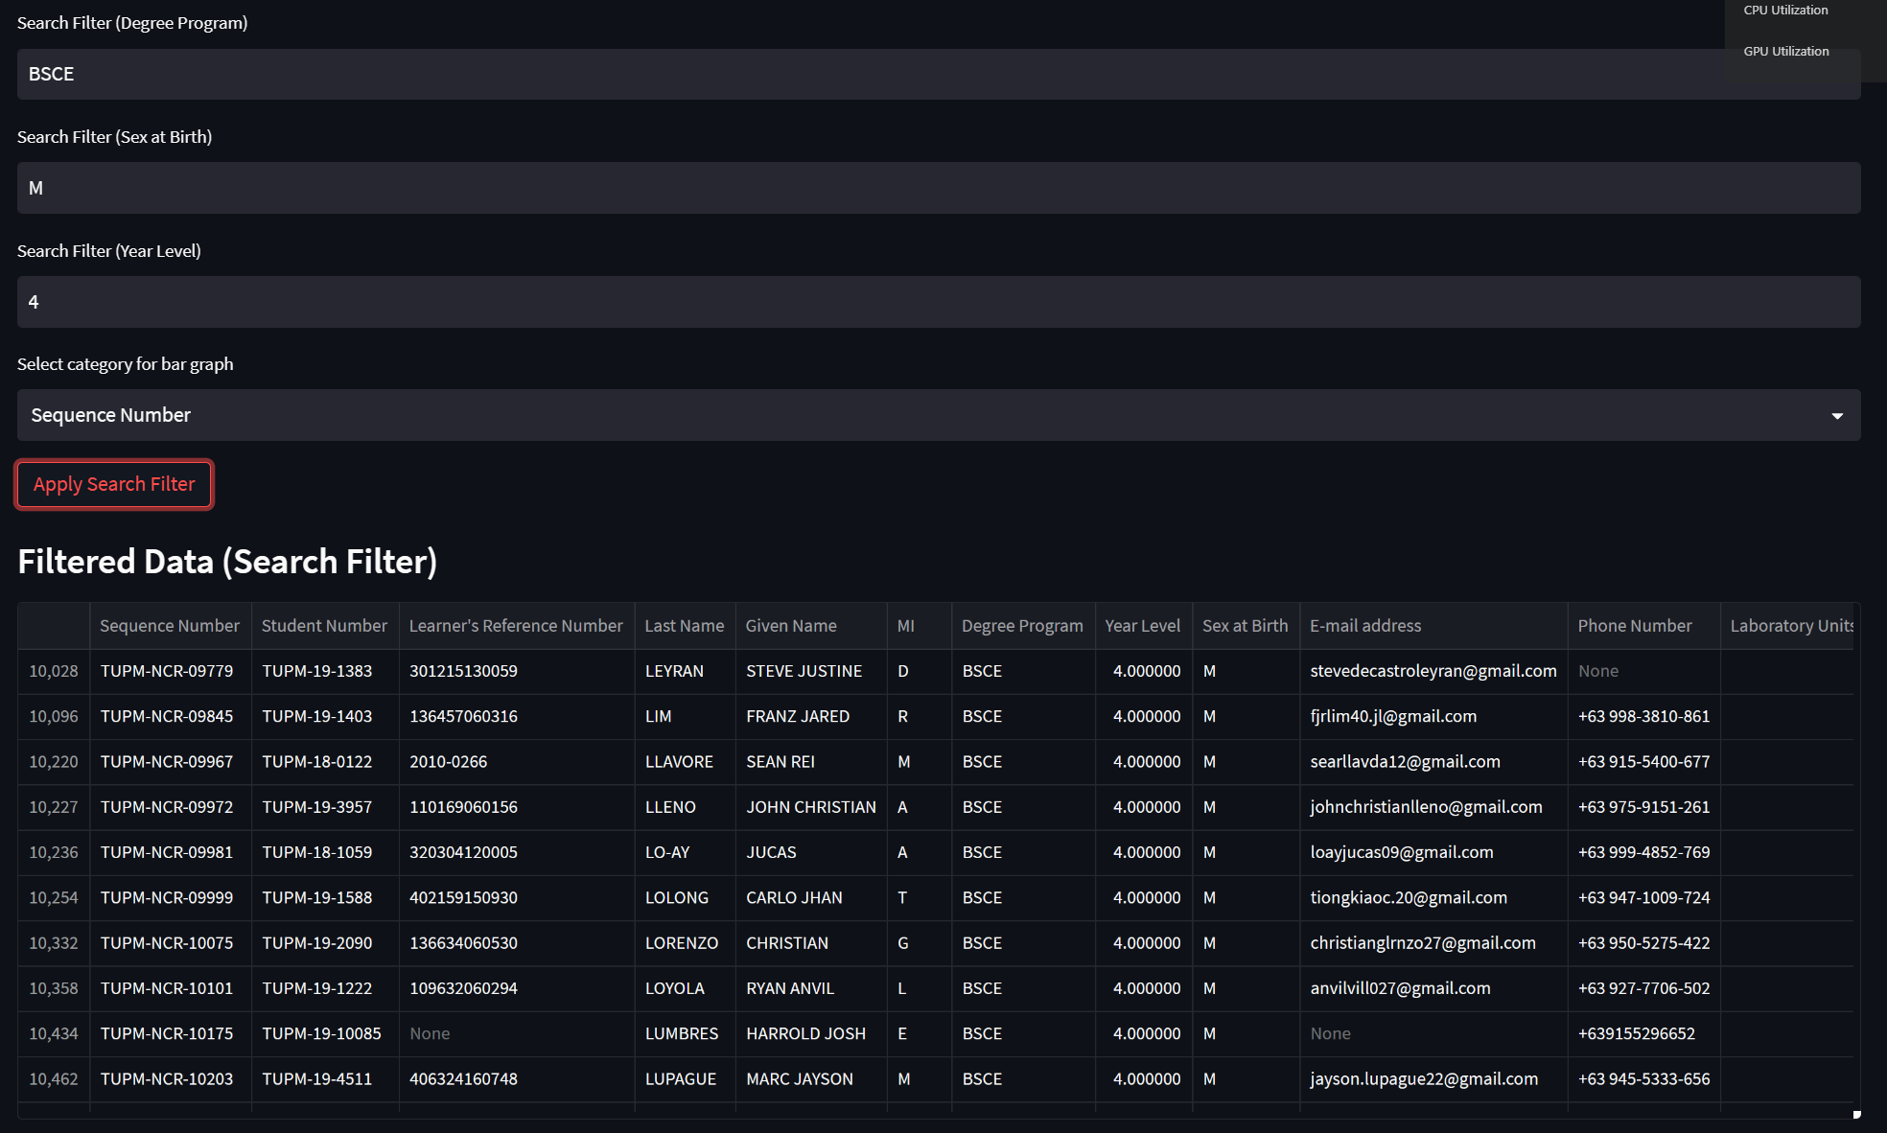

* 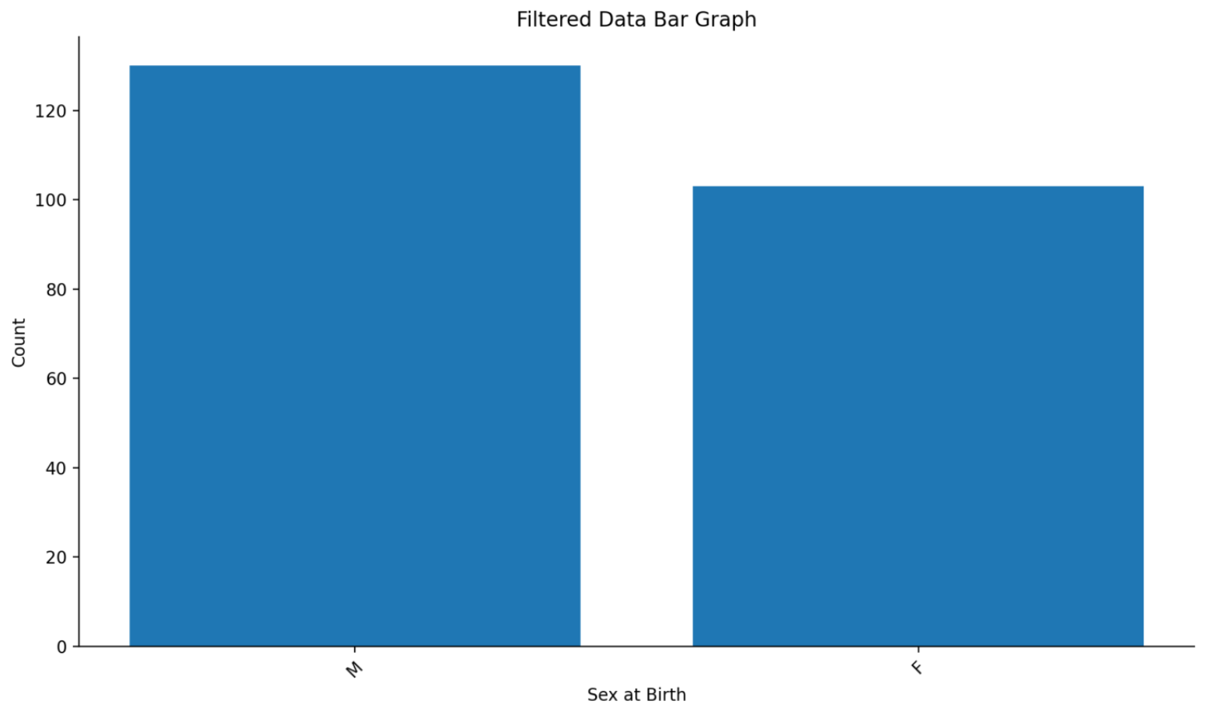Below the filtered data, a bar graph representing the filtered data will be displayed.
* The x-axis represents the selected category for the bar graph.
* The y-axis represents the count of each category value.
* The bar graph can help visualize the distribution of data based on the selected category.

1. **Download Filtering Data**

* After applying the search filters, the filtered data will be available for download as a CSV file.
* Click the "Download CSV" button to download the filtered data.
* The filtered data will be downloaded as a CSV file named "filtered_data.csv".

1. **File History**

* The TUP Data Filter System maintains a history of uploaded files.
* The file history is displayed in the sidebar.

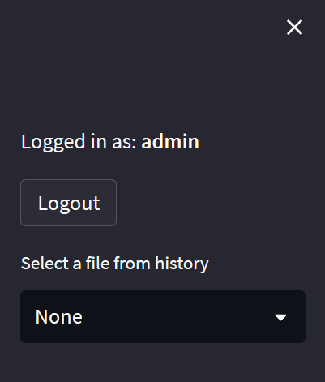

* To select a previously uploaded file from the history, click the file's name in the sidebar.

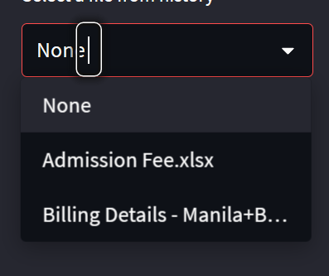

* The selected file will be displayed, and its data can be filtered and visualized as described in sections 5 and 6.
* The file history is stored in a SQLite database named "file_history.db".
  + The database is automatically created and maintained by the system.
  + No user intervention is required to manage the file history.

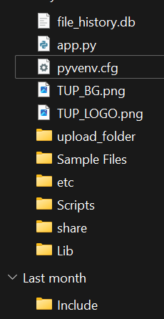

1. **Logging out** 
   * To log out of the TUP Data Filter System, click the "Logout" button in the sidebar.
   * After logging out, you will be redirected to the login page.
   * To log in again, follow the steps described in section 3.

**Important Notes:**

* **Tup Data Filtering System Only Supports xlsx files**
* **Make sure that the excel file does not have any custom header in it as the system reads the first column as your categories**